**SUPPLEMENTARY DATA**

Table 1: Study sample characteristics stratified by survey recruitment channel, In-person paper-based or online.

|  |  |  |  |
| --- | --- | --- | --- |
| **Variable\*** | **In-person survey**  **N (%)** | **Online survey**  **N (%)** | ***p*-value** |
|  | 1057 | 600 |  |
| **Aware of GetCheckedOnline** |  |  |  |
| No | 812 (77.9) | 237 (40.1) | <0.001 |
| Yes | 230 (22.1) | 354 (59.9) |  |
| **Used GetCheckedOnline** |  |  |  |
| No | 132 (59.2) | 108 (31.7) | <0.001 |
| Yes | 91 (40.8) | 233 (68.3) |  |
| **Age in years (mean (SD))** | 34.74 (13.08) | 29.49 (7.42) | <0.001 |
| **Gender** |  |  |  |
| Gender diverse | 134 (13.3) | 106 (21.6) | <0.001 |
| Men | 319 (31.8) | 151 (30.8) |  |
| Women | 551 (54.9) | 233 (47.6) |  |
| **Sexuality** |  |  |  |
| Non-heterosexual | 514 (52.1) | 306 (63.0) | <0.001 |
| Straight only | 473 (47.9) | 180 (37.0) |  |
| **Ethnicity** |  |  |  |
| Racialized | 331 (29.8) | 769 (60.2) | <0.001 |
| White | 780 (70.2) | 508 (39.8) |  |
| **Annual income** |  |  |  |
| <$20,000 | 303 (34.1) | 86 (18.9) | <0.001 |
| $20,000-$39,999 | 206 (23.2) | 112 (24.6) |  |
| $40,000-$59,999 | 152 (17.1) | 132 (28.9) |  |
| $60,000-$79,999 | 92 (10.4) | 86 (18.9) |  |
| $80,000 or more | 135 (15.2) | 40 (8.8) |  |
| **Education** |  |  |  |
| High school or less | 292 (30.4) | 123 (25.4) | 0.138 |
| Post-Secondary School | 320 (33.3) | 175 (36.2) |  |
| Bachelor or higher | 348 (36.2) | 186 (38.4) |  |
| **eHEALS Score (mean (SD))** | 30.34 (5.79) | 31.07 (5.04) | 0.023 |
| **Ease of going online (Digital access)** |  |  |  |
| Easy | 904 (90.2) | 430 (92.9) | 0.154 |
| Neither easy nor difficult | 58 (5.8) | 23 (5.0) |  |
| Difficult | 40 (4.0) | 10 (2.2) |  |
| **Health Authority** |  |  |  |
| Fraser Health | 183 (22.6) | 46 (14.8) | <0.001 |
| Interior Health | 348 (43.1) | 97 (31.3) |  |
| Island Health | 245 (30.3) | 133 (42.9) |  |
| Vancouver Coastal Health/Northern Health | 32 (4.0) | 34 (11.0) |  |
| **Previous STBBI diagnosis** |  |  |  |
| No | 691 (71.2) | 268 (52.7) | <0.001 |
| Yes | 279 (28.8) | 241 (47.3) |  |
| **Previous experience of STBBI testing barriers** |  |  |  |
| No | 380 (40.0) | 113 (21.2) | <0.001 |
| Yes | 569 (60.0) | 421 (78.8) |  |

*Percentages exclude missing values.

STBBI: Sexually transmitted and blood-borne infection; SD: Standard Deviation.

Table 2: Estimates from logistic regression assessing the relationship between survey recruitment channel and awareness and use of GetCheckedOnline.

|  |  |  |
| --- | --- | --- |
| **Variable** | **Crude relationship**  **OR (95%CI)** | **Adjusted relationship**  **OR (95%CI)** |
| **Aware of GetCheckedOnline$** |  |  |
| No | Ref | Ref |
| Yes | 5.27 (4.23, 6.57) * | 3.17 (2.18, 4.60) * |
| **Used GetCheckedOnline#** |  |  |
| No | Ref | Ref |
| Yes | 3.13 (2.20, 4.45) * | 2.47 (1.43-4.26) * |

*Significant at *p*<0.01; $Hosmer-Lemeshow (*p*=0.086), Variance Inflating Factors (VIF) <2, Model adjusted for Age, Gender, Sexuality, Ethnicity, Income, Education, eHealth literacy (operationalized as a summary eHEALS Score) and Digital Access (operationalized as ease of going online), health authority, previous STBBI diagnosis and previous experience of STBBI testing barriers; #Hosmer-Lemeshow (*p*=0.871), VIF<2, Model adjusted for Age, Gender, Sexuality, Ethnicity, Income, Education, eHealth literacy (operationalized as a summary eHEALS Score) and Digital Access (operationalized as ease of going online), previous STBBI diagnosis and previous experience of STBBI testing barriers.

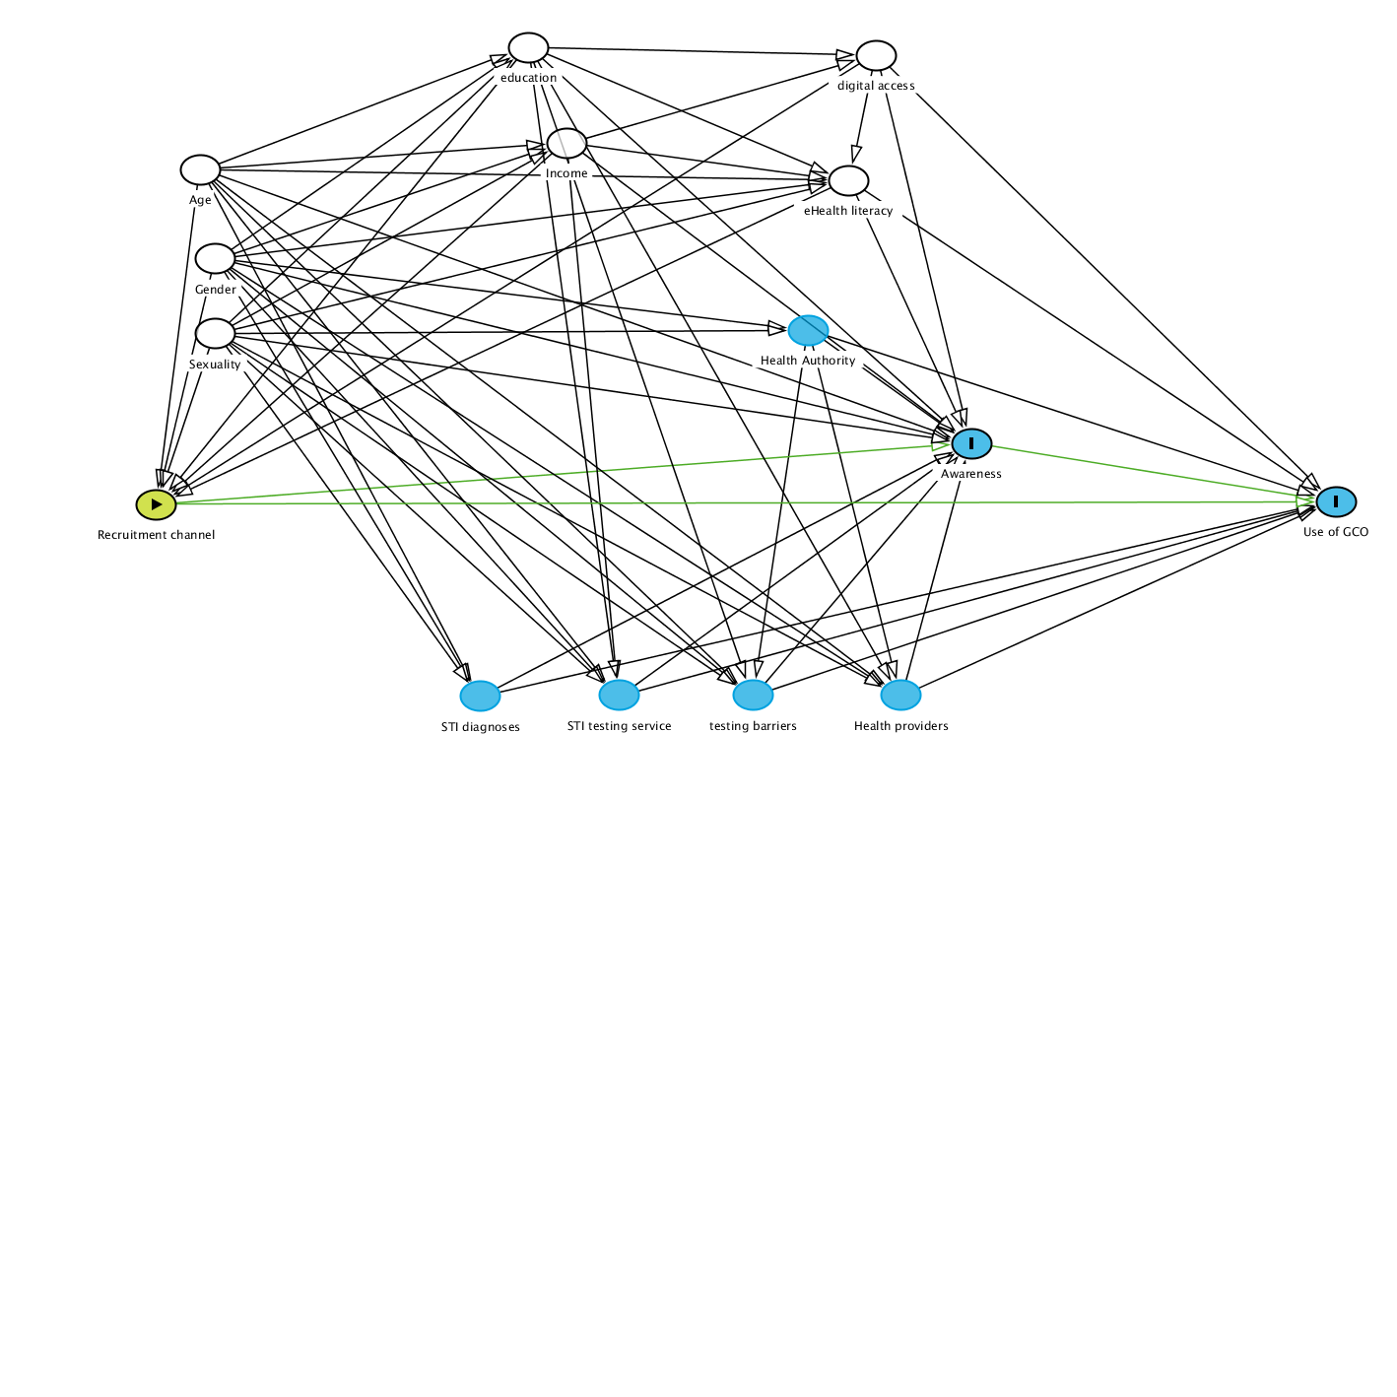

Figure 1: Causal Directed Acyclic Graph showing minimum adjustment set of variables

(Adjustment set indicated as white circles with black borders). Adjustment not required for the variable drawn as blue circles.